PROJECT REPORT

1. INTRODUCTION
   1. Overview

A subscribers to a channel on the video sharing youtube is user who has chosen to receive the channels “Subscribers” button, and each users subscription feed consists of videos publishing by channels to which the user is subscribed. The ability to subscribe to users was introduced in October 2005. YouTube began publishing a list of its most subscribed channel in April 2006. An early archive of the list dates to may 2006.

* 1. PURPOSE

Users can search for and watch videos, create a personal youtube channel, upload videos to your channel, like/comment/share other youtube videos, user scan subscribe/follow other youtube channels an users, create playlists to organize videos and group videos together.

1. PROBLEM DEFINITION & DESIGN THINKING
   1. EMPATHY MAP

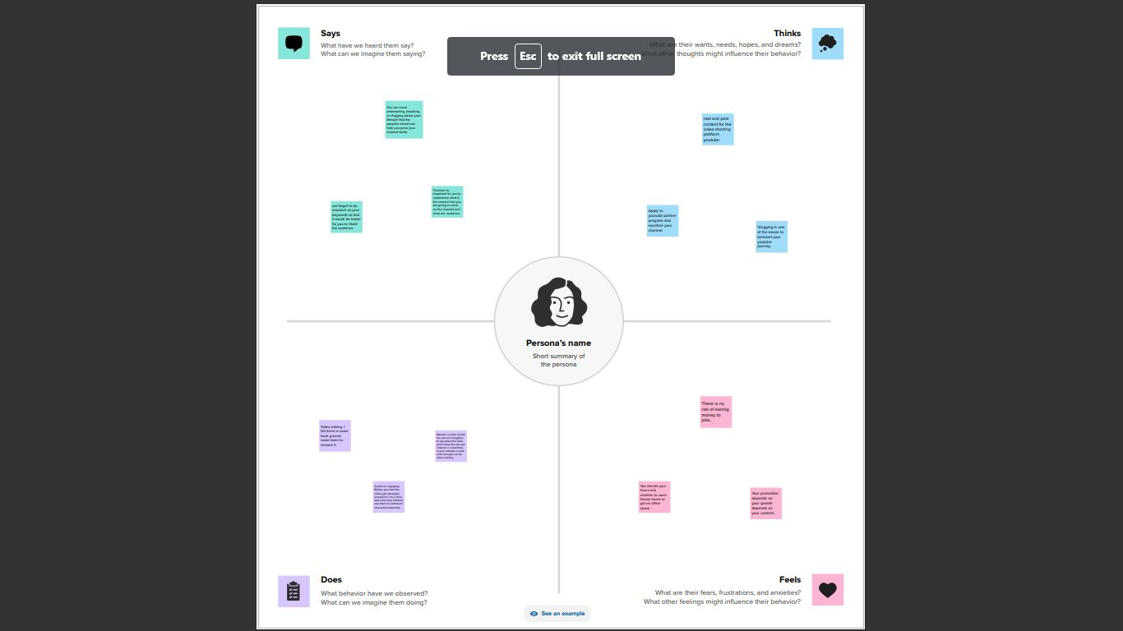­­­­

* 1. IDEATION & BRAINSTORMING MAP

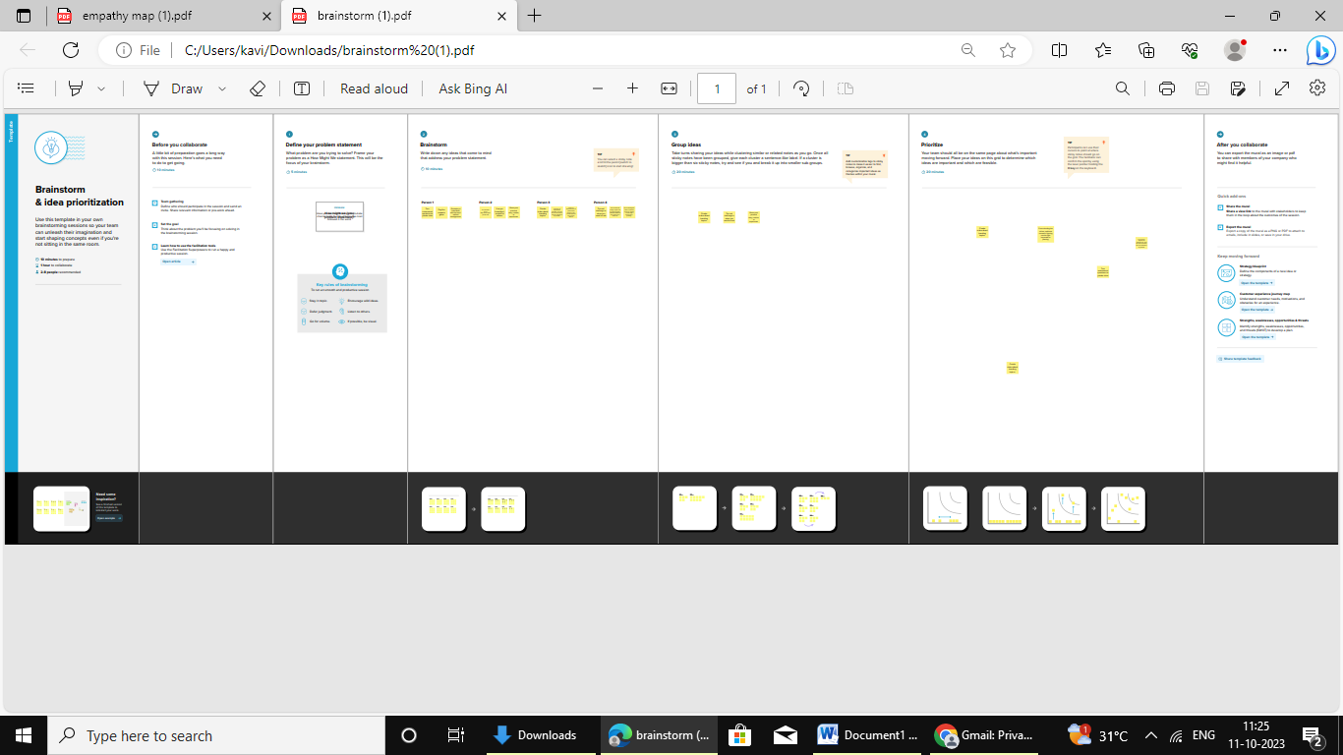

1. RESULT

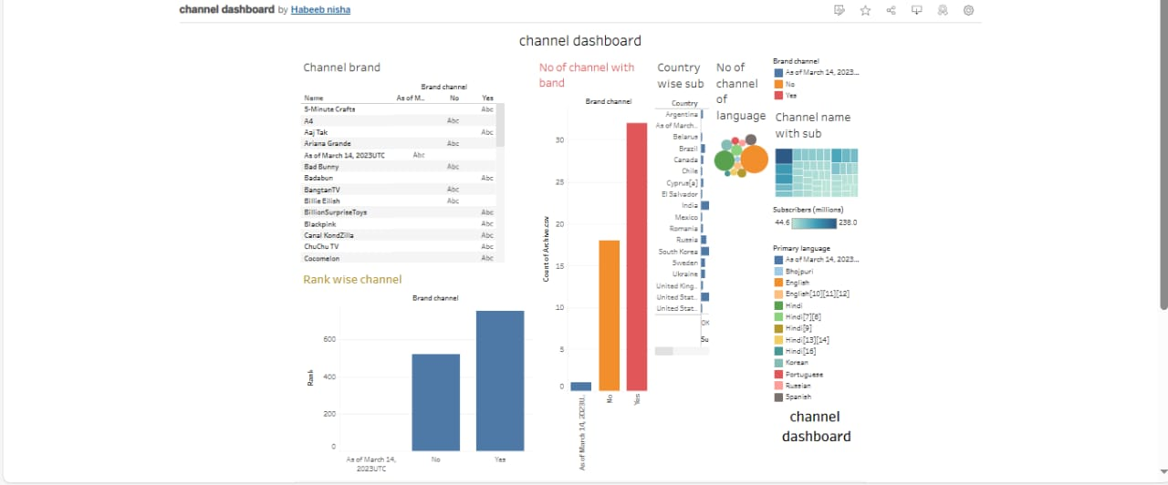

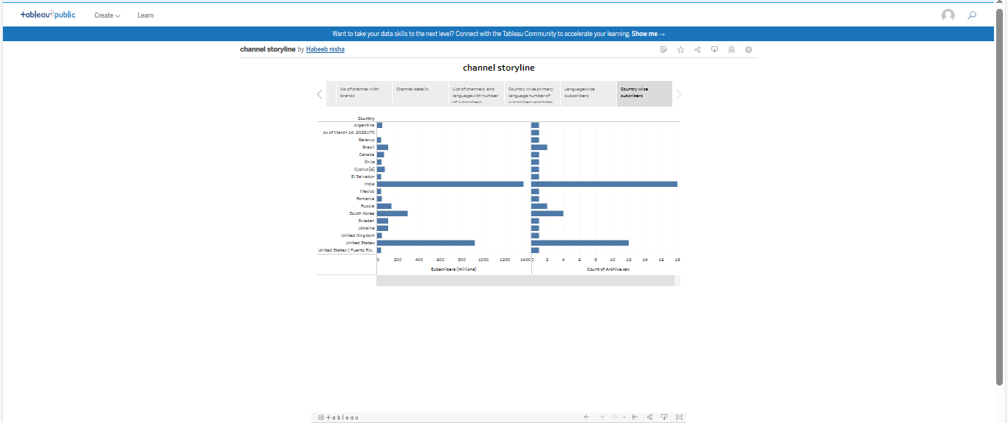

1. ADVANTAGES & DISADVANTAGES

ADVANTAGES

1.Monetization and revenue

2.Brand recognition and credibility

3.Increased engagement and interaction

DISADVANTAGES

1.Pressure for consistent content

2.Audience expectations

3.Subscriber churn

5 APPLICATIONS

1.Consistent quality content

2.Engagement strategies

3.Collaborations and cross-promotions

4.Utilizing youtube features

5.Subscriber specials and giveways

6.Optimizing thumbnails

7.Social media promotion

6 CONCLUSION

Managing a substantial subcriber base on the worlds top youtube channels involves a strategic approach, combining consistent high-quality content, engaging with the audience through various means, collabrotions, utilizing youtube features effectively, offering incentive to subscribers, optimizing video presentation, and leveraging social media for promotion. These strategies collectively contribiute to sustained growth, audience retention, and maintaining a vibrant and interactive community of subscribers. Ultimately, success in managing subscribers on top youtube channels is a blend of content excellence and strategic engagement.